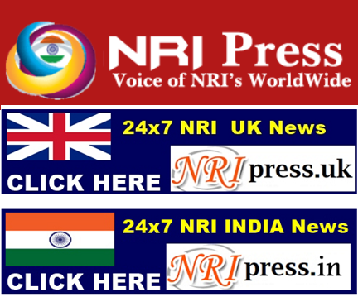 | 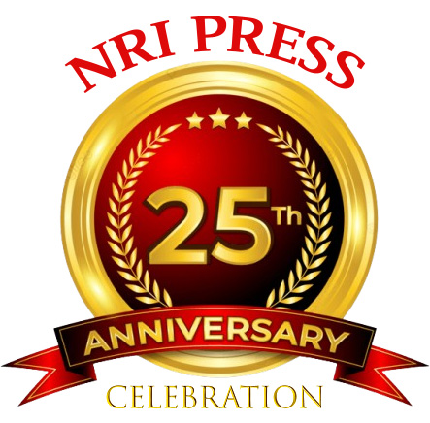 | 
Welcome NRIs to Join NRI AWARD NIGHT in 4 Countries

NOW HELPING NRIS IN INDIA THROUGH
Our Punjab Model & NRI Medical Tourism
(100s Doctors/Dentists/Hospitals/Lawyers/Businesses Added)
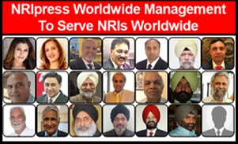 | 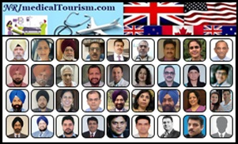
For More Information… Click Here | For More Information… Click Here

-Billions of $ REVENUE FOR PUNJAB
(Through NRImedicalTourism.com)
-Volunteers can Earn $10-$20k Part Time

IF YOU LOVE NRIs & like to SAVE PUNJAB:
JOIN OR RENEW MEMBERSHIP

- Become Co-Founder or Part of This Project & NRIpress,
Starting Jan 01, 2026
By SPONSOR NEWS &VIDEO
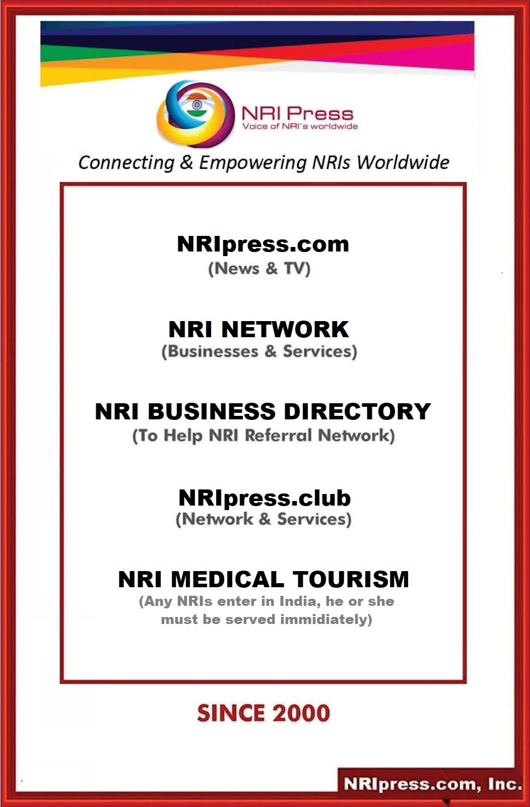

DEAR NRIs, BUSINESS OWNERS & SENIORS

- Let we Unite & Share All our Issues & Problems.
- Let we bring like-minded NRIs Worldwide under one umbrella.

NRI MUST NEED A TRUE MEDIA where NRIs voice must be heard from Whitehouse to New Delhi.
- If you already have membership, PLEASE RENEW NOW (to keep your benefits, webpage, photos and video data)
- If You are NOT Member, Please don’t ignore this Opportunity
        - Benefits: ……. Click Below:
https://nriinternet.com/NRImembership/Benefits/index.html

YOU MUST BECOME CO-FOUNDER of NRIpress

By Sponsoring

At Least One Platform Of

  - NRIpress.com
  - NRIpress.club
  - NRI Business Directory (20 Websites)
  - NRI Medical Tourism
  - NRIpress.TV (100s Debate/Yr. Shows)
  - NRIpress Awards Night

Best regards,
Admin/

C:\Users\Avtar\Desktop\Adminstration\AG\General-Fundraise-NRIs-Business_Owners-Seniors-Application-10Pages-Nov.26.2025\
Fundraise-NRIs-Business_Owners-Seniors-10Pages_Nov.26_10am.docx

NRIpress.club Membership Benefits
Category | Bio  Listing | News  Updated | Advertisements | Business Referral | Press Release | Co-Founders | Media-Rights | Functions Yearly | Hotline Services
Category | NRIpress/ your Name | News | 21 Websites | Worldwide | With 3 Photos | On Home Page of |  | Community Entertainments
Bronze.....$100 |  |  |  |  |  |  |  | Yearly function-Special Discount and better seats | Encourage to set up 24 x 7 Hot line worldwide including India to help NRIs goto
Silver.......$250
Gold.........$500
Diamond...  $1000 |  |  |  |  |  | At Business  Directory | Members can involve in management and Media rights
Platinum....
$25000
Corporate |  |  |  |  |  | At News  Media | Members can involve in management and Media rights
Media

More Benefits:
1. | Referrals & Increased Business | Referrals and positive word-of-mouth are the most effective ways to build a small business and .most trusted marketing strategy. You get normally high quality and even pre-qualified business for you.
2. | Opportunities & Connections: | - You get opportunity to meet motivated group of business owners and opens the door to talk to highly influential people.  - Connections-Networking provides you with a great source of connections and you can call them to help and align with your business goals and vision.
3. | Advice From Like-minded Business Owners: | Networking gives you the opportunity to get advice from specialized field business owners and expertise related to your business or even your personal life or family problems.
4. | Share ideas and knowledge : | Discussing your views within a group and feedback from them provides you with an opportunity to learn and avoid some of the common pitfalls they experienced.
5. | Positive Influence & Increased confidence- | By telling people who you are and what you do, then uplifting people that help you to grow as great entrepreneur. Pushing yourself to talk to other unknown professionals and entrepreneurs, it will help increase your confidence. Your business growth is dependent on talking to people and making connections.
6. | Friendship & Satisfaction from helping others: | Like-minded business owners help each other, want to grow your businesses and naturally strong friendships tend to form. When Network people help each other to solve the problems or issues within their business and get a fantastic result - there is great satisfaction.
NRIpress Member's Exclusive Benefits:
1. | You will run NRI news media in your City/State/Country…..(supported by our news room)
2. | If you own the business:  - You will get 50% discount for your business Link  - The following year you can earn free Link if you add two honest business owners as your club network.
3. | Making Extra Income: Making extra money is always a bonus. No contest. You can involve in our 20 website project. Nothing on this page is going to get you rich, but sometimes it’s just about making a few extra couple thousand dollars each month.  - You will share revenue from club membership /Sponsors/ Investment and selling rights such as NRIpress.com/USA…Canada, LA etc . you refer above three advertisements mentioned in 2 or start immediately if you have no business advertisement related to our 20 web sites mega project.
4. | You will promote your business and get popular in your community by:  - Internet Presence and being a member of Association.  - Networking Opportunities at Respective Event.  - Cross Business referrals: Member can increase their business from annual directory of our members and by attending our functions.
5. | Referral Incentive by joining individual web site netwok: For example Real estate.
6. | You will run NRI business association in your City/State/Country through membership/seminars (our association will support.)
7. | You will promote your/family sons or daughters in seminars - We will encourage them to control this project and enable them to have direct contact with CEOs/ Politicians and Entrepreneurs.
8. | You will be highly recognized and respected in NRI Community as well as local politician’s circle.
FUTURE OPPORTUNITIES TO EXPAND:

1. | As soon as we have 500 members, our plan is to negotiate for reduced rates with:  a.) Insurance Companies: Life, Retirement, health, Real Estate, and Auto Insurance.  b.) Car Dealerships or Companies with special rebate.  c.) Hotel Discounts, Rental Cars & Holidays package.  d.) Private Share Accommodation Worldwide.  e.) Loan Facilities, or Own Banking and Credit Cards to members.
2. | Hot Line Help 24 x7  - NRI seniors and needy families in your city.  - Help in India: such as Accident situation, airport, police or neighbour harasement or Other unexpected racism, brutality and corruption.
EXECUTIVE MEMBER ID CARD
for Admin/Media Executives/IT Admin

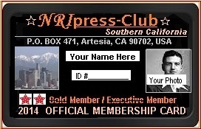  This ID Card will be issued to Diamond, Patinum, Board of Directors, News Officials, IT Investors, and senior Advisors. |  | This card can be used from white House to New Delhi when official invitation have been provided.  - Enjoy and join at Special reserved tables for press at Bollywood or Hollywood Entertainment Shows or any Political functions.  - To represent yourself as a NRI Community representative or behalf of press to local Mayors, police heads or congressmen.  - Help to raise funds for needy NRIs and NRI associations  - When traveling in India, you can use it where you feel helpful at airport, hospital, police stations or in offices. In any difficult time, you can contact local media or our head office for help.
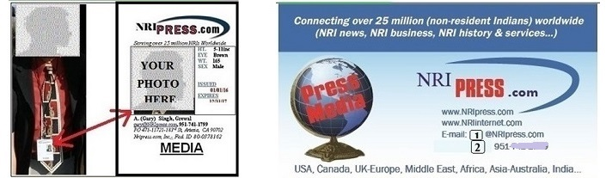
More About NRIpress.club........CLICK HERE

please give back to your nri community

MEMBERSHIP CATEGORIES:
- Basic Membership (Your Photo & Businesses will be added)
  - Bronze Member (Students & Seniors)
    - Income < 10,000/yr Free
      - All NRIs Worldwide $100.00/yr.

  - Silver Member (Association, Charity & Political Party) $250.00/yr.

Please Sponsor Saturday or Sunday Debate Video
      - Your Photo/Business/or Family Link 2x2 inch as Sponsor on video debate.

  - Gold Member (Business Owners, Acct./Realtors/Trucking/etc.) $500.00/yr.

Please Sponsor Saturday and Sunday Debate Video
      - Your Photo/Business/or Family Link 2x2 inch as Sponsor on video debate two times.

- Corporate Club Membership (Your Bio, Businesses, will be added. All Diamond and platinum Sponsors Become’ Co-Founders’ of NRIpress.in & also eligible to get 75% Discount in shares if NRIpress.in becomes Public Company.
  - Diamond Member (Sponsor Video/News/Anchor/IT) $1000.00/yr.
- Commitment $10,000 (Start with $5000 first year and $1000 yearly for corporate)
  - Mohali Office IT person- $5000 for one year.
  - Award Night- Diamond Table for family.
- Your Photo/Business/or Family Link 2x2 inch as Sponsor on video debate 4 times.

  - Platinum Member (Sponsor Server/Domains/News/Video/web) $25000.00/
- Commitment $25,000 (Start with $10,000 & $2500-$5000 yearly for corporate)
- Please Sponsor at least one:
  - Anchor- $10,000/yr.
  - Mohali Office IT Support- $5,000/yr.
  - Web Development- - $10,000/one time.
  - Award Night-- $10,000/yr. Platinum Table.
- Your Photo/Business/or Family Link 2x2 inch as Sponsor on video debate every month.

NEVER Loose Opportunity for Good Cause:
TO FILL UP APPLICATION AND FOR PAYMENTS: www.NRIpress.com or www.NRIpress.club
--then click Application

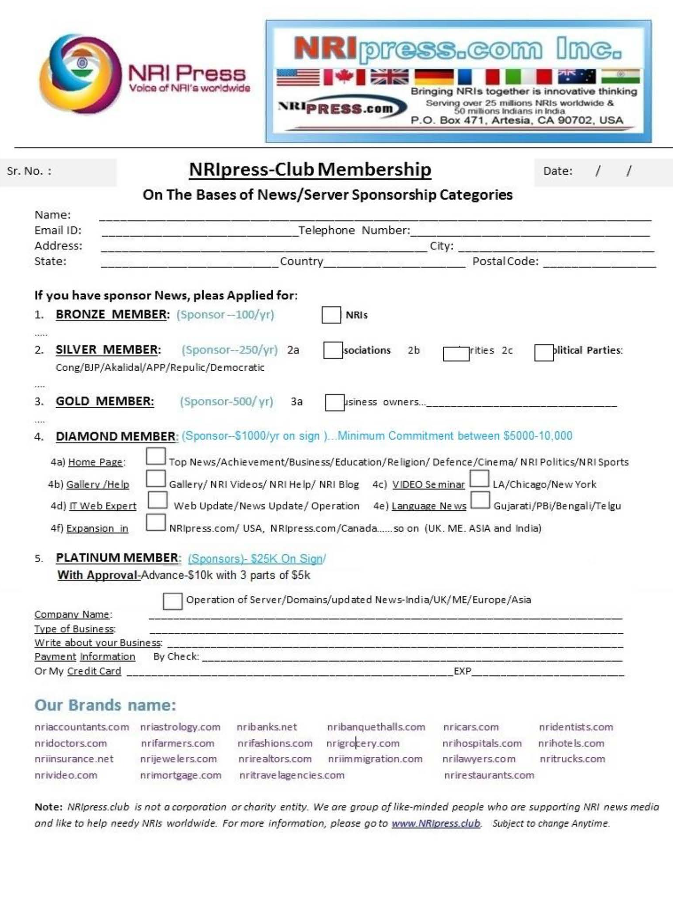

Diamond and Platinum Sponsors

who like to serve NRI Community or officially in NRI Project local or Worldwide, please fill
up this Page:

Member’s Name: ___________________ Sponsor Date: ___/___/____

Payment Yearly (Diamond or Platinum Members):

Name | 2010-2023 | 2024 | 2025 | 2026 | 2027

--- Can be Upgraded any time to Platinum Member

Note: DIAMOND & PLATINUM members may apply to get incentive shares to grow
according to their ability, time and their insert in the project:

- May involve in management, in News and IT Operation
- Platinum Members can get financial incentive according their interest, need and involvement.
If you are a Platinum Member:
- You will be able to recover your sponsorship through commission incentives.
- You will still be able to get shares of the company as mentioned on our website.
- Co-Founder members in their City or State and Co-Founder in other Countries.
- Expansion operation– Preference will be given to Diamond & Platinum Members.

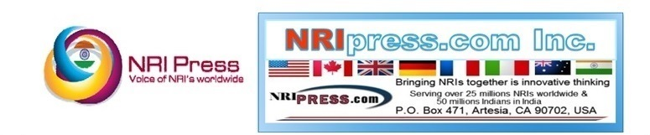
Without your support and generosity, we would not have been granted and continue
to have this project. Please Register or Renew your membership below:

Application & Membership
(Bronze to Platinum Membership)

    - FILL UP APPLICATION & Payment……CLICK

Or
    - Payments Only: CLICK

Or

  - Go to our Website, Click Application: www.NRIpress.com

Thank you for choosing to be a part of NRIpress

