 |  | 
Welcome NRIs to Join NRI AWARD NIGHT in 4 Countries

NOW HELPING NRIS IN INDIA THROUGH
Our Punjab Model & NRI Medical Tourism
(100s Doctors/Dentists/Hospitals/Lawyers/Businesses Added)
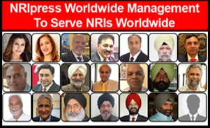 | 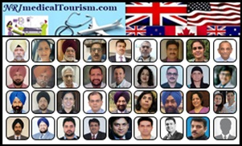
For More Information… Click Here | For More Information… Click Here

-Billions of $ REVENUE FOR PUNJAB
(Through NRImedicalTourism.com)
-Volunteers can Earn $10-$20k Part Time

IF YOU LOVE NRIs & like to SAVE PUNJAB:
JOIN OR RENEW MEMBERSHIP

- Become Co-Founder or Part of This Project & NRIpress,
Starting Jan 01, 2026
By SPONSOR NEWS &VIDEO
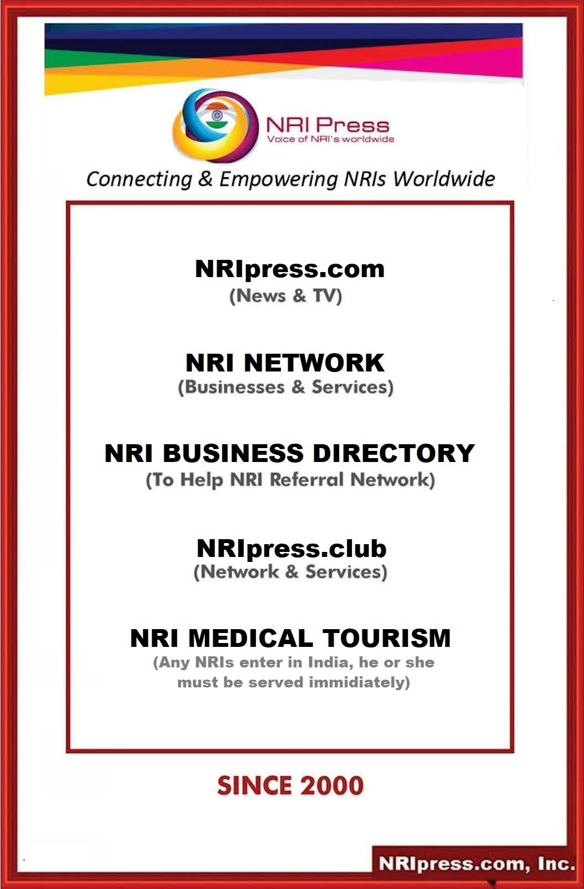

Dear NRIs, BUSINESS OWNERS & SENIORS
- Let we Unite & Share All our Issues & Problems.
- Let we bring like-minded NRIs Worldwide under one umbrella.

NRI MUST NEED A TRUE MEDIA where NRIs voice must be heard from Whitehouse to New Delhi.
- If you already have membership, PLEASE RENEW NOW (to keep your benefits, webpage, photos and video data)
- If You are NOT Member, Please don’t ignore this Opportunity
      - Benefits: ……. Click Below:
https://nriinternet.com/NRImembership/Benefits/index.html

YOU MUST BECOME CO-FOUNDER of NRIpress

By Sponsoring

At Least One Platform Of

  - NRIpress.com
  - NRIpress.club
  - NRI Business Directory (20 Websites)
  - NRI Medical Tourism
  - NRIpress.TV (100s Debate/Yr. Shows)
  - NRIpress Awards Night
Best Regards
Admin/

C:\Users\Avtar\Desktop\Adminstration\AG\Aggrement-Fundraise-CONTRACT-11-Management-Cities-19Pages-Nov.26.25\Fundraise-Contract-11-Management-Cities-Country-19Pages-Nov.26.25_CS_10.35am.docx

Membership Benefits
Category | Bio  Listing | News  Updated | Advertisements | Business Referral | Press Release | Co-Founders | Media-Rights | Functions Yearly | Hotline Services
Category | NRIpress/ your Name | News | 21 Websites | Worldwide | With 3 Photos | On Home Page of NRIpress |  | Community Entertainments
Bronze.....$100 |  |  |  |  |  |  |  | Yearly function-Special Discount and better seats | Encourage to set up 24 x 7 Hot line worldwide including India to help NRIs goto
Silver.......$250 |  |  |  |  |  |  |  | Yearly function-Special Discount and better seats
Gold.........$500 |  |  |  |  |  |  |  | Yearly function-Special Discount and better seats
Diamond...  $1000 |  |  |  |  |  | At Business  Directory | Members can involve in management and Media rights | Yearly function-Special Discount and better seats
Platinum....
$25000
Corporate |  |  |  |  |  | At News  Media | Members can involve in management and Media rights | Yearly function-Special Discount and better seats
Media

More Benefits:
1. | Referrals & Increased Business | Referrals and positive word-of-mouth are the most effective ways to build a small business and .most trusted marketing strategy. You get normally high quality and even pre-qualified business for you.
2. | Opportunities & Connections: | - You get opportunity to meet motivated group of business owners and opens the door to talk to highly influential people.  - Connections-Networking provides you with a great source of connections and you can call them to help and align with your business goals and vision.
3. | Advice From Like-minded Business Owners: | Networking gives you the opportunity to get advice from specialized field business owners and expertise related to your business or even your personal life or family problems.
4. | Share ideas and knowledge : | Discussing your views within a group and feedback from them provides you with an opportunity to learn and avoid some of the common pitfalls they experienced.
5. | Positive Influence & Increased confidence- | By telling people who you are and what you do, then uplifting people that help you to grow as great entrepreneur. Pushing yourself to talk to other unknown professionals and entrepreneurs, it will help increase your confidence. Your business growth is dependent on talking to people and making connections.
6. | Friendship & Satisfaction from helping others: | Like-minded business owners help each other, want to grow your businesses and naturally strong friendships tend to form. When Network people help each other to solve the problems or issues within their business and get a fantastic result - there is great satisfaction.
NRIpress Member's Exclusive Benefits:
1. | You will run NRI news media in your City/State/Country…..(supported by our news room)
2. | If you own the business:  - You will get 50% discount for your business Link  - The following year you can earn free Link if you add two honest business owners as your club network.
3. | Making Extra Income: Making extra money is always a bonus. No contest. You can involve in our 20 website project. Nothing on this page is going to get you rich, but sometimes it’s just about making a few extra couple thousand dollars each month.  - You will share revenue from club membership /Sponsors/ Investment and selling rights such as NRIpress.com/USA…Canada, LA etc . you refer above three advertisements mentioned in 2 or start immediately if you have no business advertisement related to our 20 web sites mega project.
4. | You will promote your business and get popular in your community by:  - Internet Presence and being a member of Association.  - Networking Opportunities at Respective Event.  - Cross Business referrals: Member can increase their business from annual directory of our members and by attending our functions.
5. | Referral Incentive by joining individual web site netwok: For example Real estate.
6. | You will run NRI business association in your City/State/Country through membership/seminars (our association will support.)
7. | You will promote your/family sons or daughters in seminars - We will encourage them to control this project and enable them to have direct contact with CEOs/ Politicians and Entrepreneurs.
8. | You will be highly recognized and respected in NRI Community as well as local politician’s circle.
FUTURE OPPORTUNITIES TO EXPAND:

1. | As soon as we have 500 members, our plan is to negotiate for reduced rates with:  a.) Insurance Companies: Life, Retirement, health, Real Estate, and Auto Insurance.  b.) Car Dealerships or Companies with special rebate.  c.) Hotel Discounts, Rental Cars & Holidays package.  d.) Private Share Accommodation Worldwide.  e.) Loan Facilities, or Own Banking and Credit Cards to members.
2. | Hot Line Help 24 x7  - NRI seniors and needy families in your city.  - Help in India: such as Accident situation, airport, police or neighbour harasement or Other unexpected racism, brutality and corruption.
EXECUTIVE MEMBER ID CARD
for Admin/Media Executives/IT Admin

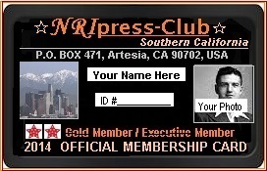  This ID Card will be issued to Diamond, Patinum, Board of Directors, News Officials, IT Investors, and senior Advisors. |  | This card can be used from white House to New Delhi when official invitation have been provided.  - Enjoy and join at Special reserved tables for press at Bollywood or Hollywood Entertainment Shows or any Political functions.  - To represent yourself as a NRI Community representative or behalf of press to local Mayors, police heads or congressmen.  - Help to raise funds for needy NRIs and NRI associations  - When traveling in India, you can use it where you feel helpful at airport, hospital, police stations or in offices. In any difficult time, you can contact local media or our head office for help.
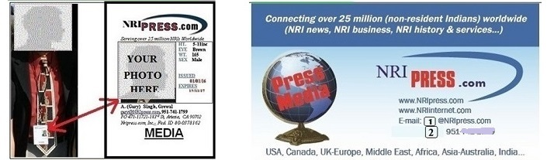
More About NRIpress.club........CLICK HERE

NRIPRESS.COM INCORPORATED

AGREEMENT

This Agreement (the “Agreement”) is entered into as of Oct 01, 2025, by and between NRIpress.com Incorporated, a California corporation (the “Company”), USA and __________Your name and full address____________________,USA pursuant to the Company’s 2009 policies, continue expansion worldwide under the California NRIpress.com domain model. NRIpress.club domain is also associated with NRIpress.com to help NRIs worldwide
- NRIpress.com, Inc: In 2007, NRIpress.com, Inc. was established under the State of California, USA to provide current NRI news worldwide. To minimize working capital requirements, our very qualified entrepreneurs, web developers and IT Professional who are holding incentive shareholders of the company, are updating news and operation 24 x 7.
- NRIinternet.com (Community local news): Around 2000, NRI news was started by adding (NRI and Internet name combined for NRI news media. It is still running a non-stop operation of NRI news under the umbrella of GTI. NRIinternet.com became NRI community services news media worldwide.
- NRI Business Directory, (20 Websites Network include NRI accountants, NRI doctors, NRI realtors etc.) were established. In today’s world, networking is a necessity. It also includes more business opportunities, broader and deeper knowledge, rewards typically include discounts, credits, or cash, turning customers into brand advocates and leveraging the power of word-of-mouth marketing to drive growth and strengthen customer relationships.
- NRIpress.Club: In 2014, NRIpress.com, Inc. has already brought unprecedented success of NRIpress.Club, SC, California and now expanding worldwide.
- NRImedicalTourism.com: India’s low-cost healthcare fuels NRI Medical Tourism boom, shorter waiting times, and family support during recovery. NRIs also often return to India for emotional comfort and being treated in familiar environments. Our mission is to ensure that every NRI entering Punjab receives top-notch medical care and assistance through our dedicated services.

Dear NRI Associates,

You have shown an interest in joining NRI Corporate Club Membership where you can serve NRIs local projects as well as Worldwide expansion programs. Our basic Membership starts with Bronze-Silver-Gold-Diamond and Platinum Membership.
- Corporate Club membership starts from Diamond to Platinum Membership.
- Only corporate (start with Diamond) Members in your city (11-21) can enjoy Media Executive position and earned revenue.

Let us understand how it works. In old days, when new entities or Businesses were being established as a corporation, friends or relatives buy some shares in the company for moral support. They get some benefits or loss in papers. Some qualified shareholders become officers to run the corporation.
- Now Staring 2000, new technology allows each of us to become a member of .com, how much we input as a member and share our output. Dot com (.COM) unite us to work as a team without liabilities.

Let we more clarify in our case: NRIpress is a corporation operating server as media company .com in the air, 20 website ‘.com’ have also been in the air for the past 25 years.
- Dot (.com) is the only in the world which is run by servers and servers’ cost will be borne by some people who own the corporation. Our unique idea, unique technology and 25 years in business allow us to recognize honest entrepreneurs who can understand new concepts.

-------------

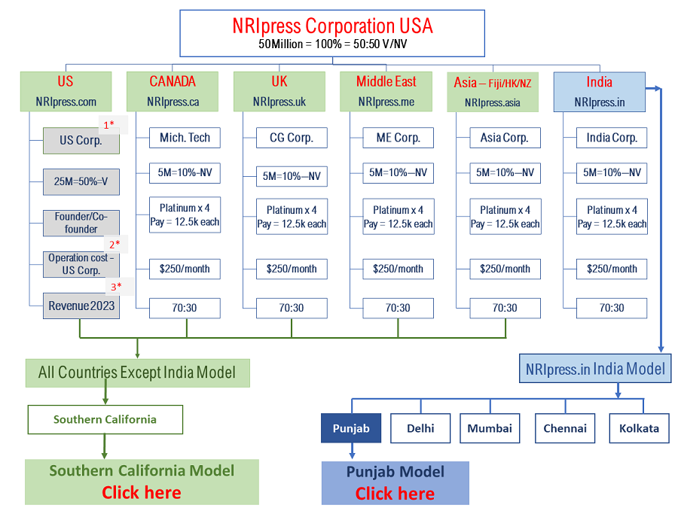

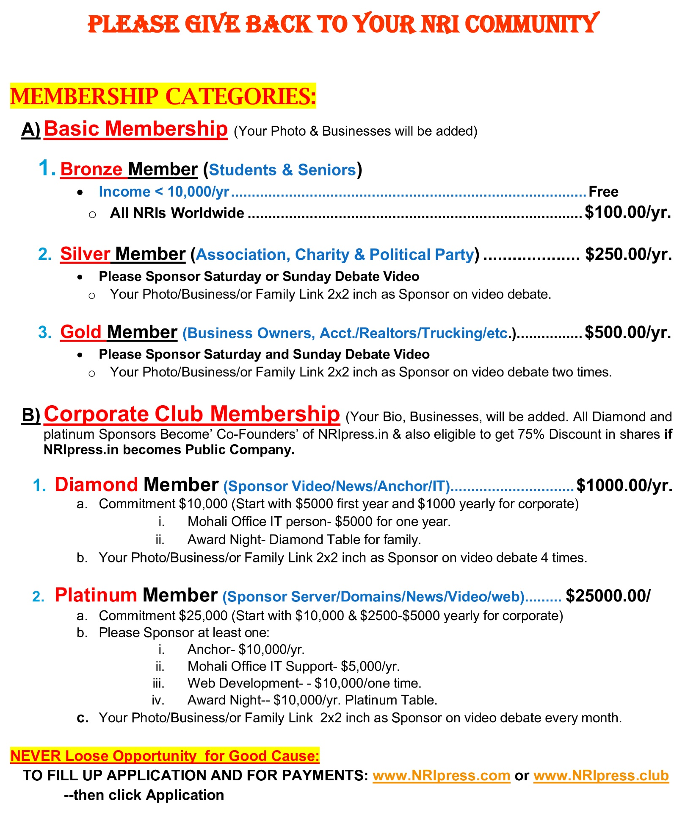

Now 25 years, a media weapon, helps us in expanding as medical tourism and ‘. club’ enforcing 11 to 21 entrepreneurs in one particular city to set up own model, enjoy media power, generate revenue and share maximum output by providing small percentage to NRIpress.

IT entrepreneurs, SERVER, Lawyers and NRIpress Professionals work behind the whole project to run 24x7 without any hassle for all of us.

Administration Body (11-21) in Each State where NRI population Min 1000: Follow California LA Model

We elect carefully NRI Entrepreneurs, Business Owners, and IT individuals who have a vision and like to help NRI Community worldwide.
- Each Member must attend monthly zoom meeting (min 75%).
- Each Member must participate in yearly Award Night prog.
- Each Member must provide at least 2 sponsors (0.5k each) out of 20 websites or video or news sponsors. Ending date is Dec31, each year.
- Each member has access to generate revenue from 20 websites, sponsor news and video, membership, award night tables and sponsors etc. Revenue sharing chart is also attached here.
- Each member shall ENJOY AS MEDIA EXECUTIVE in their city area or can involve in worldwide projects.

. ---------

How Smart Social Entrepreneurs & Business Owners
Can become Diamond/Platinum-Corporate Members
without Investment & may Earn more than $20K per year
- Go to NRIpress and Fill Application as Diamond Member.
- Two members must endorse your name.
- On signing a contract, you must pay $1k for this year & get it back if you have added 2 sponsors.
- Now you are eligible as DIAMOND Member of 11-21 Board members
- Work on 20 websites, get sponsorship $0.5k-1.0k, & talk to our business owners.

YOUR INCOME START HERE AS MEDIA EXECUTIVE:

TO COMPENSATE YOUR SERVICES, OUR REVENUE SHARING POLICY IS:
- REVENUE: Any revenue generated by you, 33,33%, will go to NRIpress.com Inc, 33.33% to IT people and 33.33% to your account.
- You will share 50:50 with other team members if you generate revenue with the help of that member.
 | REVENUE FROM Membership | TYPE | COST/ Yearly | Req-Min. | Total Revenue | NRIpress | IT | Your Earning
 |  |  |  |  |  | 30% | 30% | 40%
1. | Bronze | General | $100 | 100 | 100member x $100  = $10,000 | $3,000 | $3,000 | $ 4000
> | Silver | Associa-tions | $250 | 50 | 50 X $250/yr.  = $12,500 | $3,750 | $3,750 | $ 5,000
> | Gold | Businesses, Acct/Realtors/ Doctor/ etc. | $500 | 3 each x 20 webs | 3members x 20 websites x $500 each= $30,000 | $9,000 | $9.000 | $ 12,000
> | Diamond | Rich Sponsors | $1000 min. Start | 5 | Sponsors News/Club Members…  5 members x $1000 = $5,000 | $1,500 | $1,500 | $ 2,000
> | Platinum | Corporate/ Lifetime | $10,000 min. Start | 1 | Sponsors of News/Co-Founders ... 3 members x $10,000 = $30,  000 | $9,000 | $9.000 | $ 12,000
2 | Revenue from Web sites Development: |  |  |  | Already set up. No advance $ to India….10 websites/yr x $1000 | $3,000 | $3,000 | $ 4,000
3 | Selling Rights in North America, Europe, Asia @India |  |  |  | Each City $10,000 Average x 5 | $15,000 | $15,000 | $20,000
4 | Finder’s fees: |  |  |  | You will get 20% cash of total investment as finder fees or subject to mutual further agreement. | ???? |  | ???
5 | If you like to involve in rights/franchise for your city or even other City/State or Country, you bid. |  |  |  | 33% discount to you | ??? |  | ???

Starting Oct 01, 2025, YOUR NAME’s designation will be as_______, California

Starting March 15, 2025, your duties will include:
- News, Video and press releases by covering the NRI events in surrounding areas.
- NRIpress.club activities include: To help Needy NRIs, to promote NRI Businesses, Encourage NRI Youths, Organize Annual Functions and seminars to honor the best and the brightest of our NRIs and help to set up NRIpress-Club in major cities of the world.
- YOU will also attend the meetings of NRIpress-club for further development and press coverage.
- YOU should also coordinate with our worldwide operation to update news, videos and functions.
- All data of news/Video/Photos and other related software and products shall be the property of NRIpress
- Press release must be done within 24-48 hours: This is general practice in news media, and all the team members are anxious to make a press release ASAP.
- In 2023, we expect that any event finished, within hours photo or video shall be posted through email or other IT directions.

IT APPLIES ONLY IF NRIpress.com Inc. becomes PUBLIC COMPANY:
- Death of Optionee; No Assignment: The rights of the Optionee under this Agreement may not be assigned or transferred except by will or by the laws of descent and distribution may be exercised during the lifetime of the Optionee only by such Optionee.
- Representations and Warranties of Optionee: Optionee represents and warrants that this Option is being acquired by Optionee for Optionee’s personal account, for investment purposes only, and not with a view to the distribution, resale or other disposition thereof.
- Right of First Refusal: The Shares acquired pursuant to the practice of this Option may be sold by the Optionee only in compliance with the provisions. Prior to any intended sale, Optionee shall first give written notice (the “Offer Notice”) to the company.
- Company’s Repurchase Right: The Company shall have the right (but not the obligation) to repurchase (the “Repurchase Right”) any, or all of the Shares acquired pursuant to the exercise of this Option in the event that the Optionee’s Continuous
- Restrictive Legends: Optionee hereby acknowledges that federal securities laws and the securities laws of the state in which he or she resides may require the placement of certain restrictive legends upon the Shares issued upon exercise of this Option, and Optionee hereby consents to the placing of any such legends upon certificates evidencing the Shares as the Company, or its counsel, may deem necessary or advisable.
- Adjustments Upon Changes in Capital Structure: In the event that the outstanding shares of Common Stock of the Company are hereafter increased or decreased or changed into or exchanged for a different number or kind of shares or other securities of the Company by reason of recapitalization, stock split, combination of shares, reclassification, stock dividend
- Change in Control. In the event of a Change in Control: The right to exercise this Option shall accelerate automatically and vest in full (notwithstanding the provisions of Section 2 above) effective as of immediately prior to the consummation of the Change in Control unless this Option is to be assumed by the acquiring or successor entity (or parent thereof) or new.
- Limitation of Company’s Liability for Non-issuance--The Company agrees to use its reasonable best efforts to obtain from any applicable regulatory agency such authority or approval as may be required in order to issue and sell the Shares to the Optionee pursuant to this Agreement.
- No Employment Contract Created--Neither the granting of this Option nor the exercise here of shall be construed as granting to the Optionee any right with respect to continuance of employment by the Company or any of its subsidiaries.
- Rights as Stockholder--The Optionee (or transferee of this option by will or by the laws of descent and distribution) shall have no rights as a stockholder with respect to any Shares covered by this Option until such person has duly exercised this Option, paid the Exercise Price and become a holder of record of the Shares purchased.
- “Market Stand-Off” Agreement- Optionee agrees that, if requested by the Company or the managing underwriter of any proposed public offering of the Company’s securities, Optionee will not sell or otherwise transfer or dispose of any Shares held by Optionee without the prior written consent of the Company or such underwriter, as the case may be, during such period of time, not to exceed 180 days following the effective date of the registration statement filed by the Company with respect to such offering, as the Company or the underwriter may specify.
- Interpretation-- This Option is granted pursuant to the terms of the Plan and shall in all respects be interpreted in accordance therewith. The Administrator shall interpret and construe this Option and the Plan, and any action, decision, interpretation or determination made in good faith by the Administrator shall be final and binding on the Company and the Optionee. As used in this Agreement, the term “Administrator” shall refer to the committee of the Board of Directors of the Company appointed to administer the Plan, and if no such committee has been appointed, the term Administrator shall mean the Board of Directors.
- Notices-- Any notice, demand or request required or permitted to be given under this Agreement shall be in writing and shall be deemed given when delivered personally or three (3) days after being deposited in the United
- Governing Law--The validity, construction, interpretation, and effect of this Option shall be governed by and determined in accordance with the laws of the State of California.
- Severability-Should any provision or portion of this Agreement be held to be unenforceable or invalid for any reason, the remaining provisions and portions of this Agreement shall be unaffected by such holding.
- Attorneys’ Fees--If any party shall bring an action in law or equity against another to enforce or interpret any of the terms, covenants and provisions of this Agreement, the prevailing party in such action shall be entitled to recover reasonable attorneys’ fees and costs.
- Counterparts-- This Agreement may be executed in two or more counterparts, each of which shall be deemed an original and all of which together shall be deemed one instrument.
- California Corporate Securities Law-- The sale of the shares that are the subject of this Agreement has not been qualified with the Commissioner of Corporations of the State of California and the issuance of such shares or the payment or receipt of any part of the consideration therefor prior to such qualification is unlawful, unless the sale of such shares is exempt from such qualification by Section 25100, 25102 or 25105 of the California Corporate Securities Law of 1968, as amended. The rights of all parties to this Agreement are expressly conditioned upon such qualification being obtained, unless the sale is so exempt.
- STOCK AWARD PLANS AND SHARES RESERVED FOR FUTURE ISSUANCE: will be issued in exchange of services if there is any agreement.
- If any reason, services were not performed (photos, video or press release) on time, NRIpress.com Inc.’s management have the right to provide the contract to the third party. Both Parties have the right to provide one month notice and there will be no liability.
- Due to security reasons, all web sites, data or other costumer data will be the property of NRIpress.com, Inc. or new company as NRIpress.in That all the parties shall keep confidential the names, telephone numbers, telex/fax numbers. And all information regarding clients, relationships arising out of any correspondence being considered by the parties hereto.
- If you are officially a shareholder of NRIpress.in like other shareholders on the base of exchange services. Still, If any reason, you are unable to perform duties, NRIpress.in. has the right to get services from third party but earned shares shall be provided to you in good faith. NRIpress.in shall not be responsible for any liability except providing earned shares.
- Our NRIpress.com or NRIpress.in including other websites have a great place to collect information – from transactions and payments to purchasing and browsing history, newsletter signups, online enquiries and customer requests. This data must be protected. We took full responsibility in hosting area, security of passwords, data security and news control in US office for the benefit of all shareholders and network team.
- You, other IT supporters and salespeople must have good communication to keep quality work in line such as news, photos, videos and interviews on video to generate revenue with the directions of NRIpress.com, Inc. USA or NRIpress.in

A written agreement is one of the most important communication tools for both Parties. In California, there must be a written contract for all Projects.

Dear NRI, Media is a weapon

NRIpress, 25 years in NRI services, can serve as a weapon or serve as a powerful tool for good, non-profit NRIpress.club organizations to raise awareness, mobilize support, and inspire action for their causes.
- Raising awareness and education- Inform the public about important issues, from social justice and human rights to environmental concerns and public health crises. A prime example is the #MeToo movement, which used a hashtag to give voice to sexual harassment victims and force accountability.
- Promoting fundraising- Social media platforms in particular have revolutionized how non-profits raise funds. Features like Facebook's "Donate" button and Instagram's donation stickers make giving seamless and accessible.
- Using emotional and visual storytelling- Powerful storytelling through video and compelling imagery is one of media’s greatest strengths for charitable causes. By sharing the real-life stories of individuals and communities who have been helped, organizations create an emotional connection with donors. Save the Children, for example, created videos showing the plight of children in war zones to help donors empathize with them.

- Driving policy and societal change
  - By shaping public opinion, media can influence legislation and societal norms

If You become Shareholder in NRIpress.in Corporation after Launched Public company:

SUBJECT TO CERTAIN RESTRICTIONS ON TRANSFER AND A RIGHT OF FIRST REFUSAL IN FAVOR OF THE COMPANY AND/OR ITS NOMINEE & to be approved by Company’s lawyer ………………. [Signature Page Follows]

IN WITNESS WHEREOF, the parties have executed this Agreement as of the date first above written.

THE COMPANY: OPTIONEE:

NRIPRESS.COM INCORPORATED

By: Officer of the Company YOUR NAME HERE

(Signatures)

Its: Signed SIGNED

Date: __ /__ /____

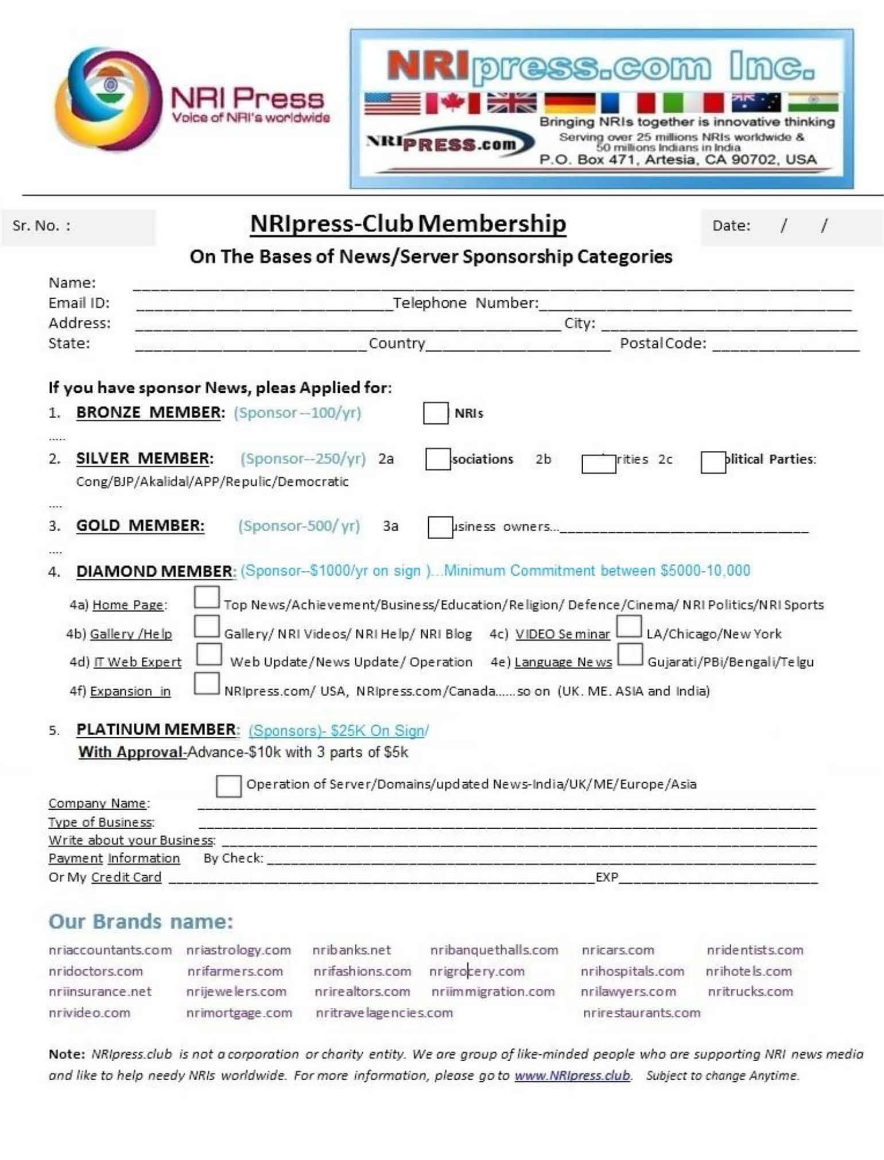
Diamond and Platinum Sponsors

who like to serve NRI Community or officially in NRI Project local or Worldwide, please fill up this Page:

Member’s Name: ___________________ Sponsor Date: ___/___/____

Payment Yearly (Diamond or Platinum Members):
Name | 2010-2023 | 2024 | 2025 | 2026 | 2027

--- Can be Upgraded any time to Platinum Member

Note: DIAMOND & PLATINUM members may apply to get incentive shares to grow according to their ability, time and their insert in the project:
- May involve in management, in News and IT Operation
- Platinum Members can get financial incentive according their interest, need and involvement.
If you are a Platinum Member:
- You will be able to recover your sponsorship through commission incentives.
- You will still be able to get shares of the company as mentioned on our website.
- Co-Founder members in their City or State and Co-Founder in other Countries.
- Expansion operation– Preference will be given to Diamond & Platinum Members.

Without your support and generosity, we would not have been granted and continue to have this project. Please Register or Renew your membership below:

Application & Membership
(Bronze to Platinum Membership)

    - FILL UP APPLICATION & Payment……CLICK

Or
    - Payments Only: CLICK

Or

  - Go to our Website, Click Application: www.NRIpress.com

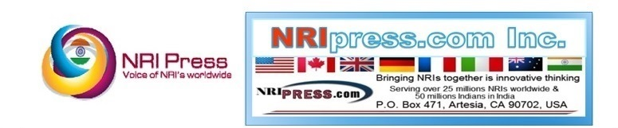
Thank you for choosing to be a part of NRIpress

